Laser Writer(DWL66)
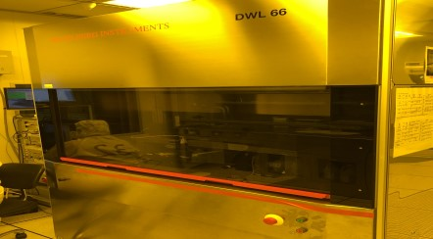
Maskless lithography
Accept .dxf .gds file type
dxf and gds files need to be drawn with " Closure Polyline ".

Sample size: up to 5 inches, minimum size 1cm square (4mm border required)
Minimum line width: 0.7 um
Stable line width: 2 um (using s1813G photoresist)
Alignment error: about 0.5um

